Dan Benson

CTEC145 Web Server Technology

Command Book Page 2

4/24/16

**To Display All Users**

cut -d: -f1 /etc/passwd

**Add User**

sudo adduser new\_username

or

sudo useradd new\_username

**To remove/delete a user**

sudo userdel username

sudo rm -r /home/username (delete user directory, use caution)

**Modify Username**

usermod -l new\_username old\_username

**Change User Paasword**

sudo passwd username

**Change User Shell**

sudo chsh username

**Change User Information**

sudo chfn username

#### Install AWS Linux updates:

sudo yum update -y

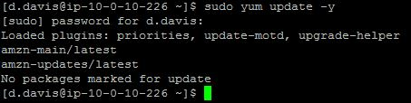[View in a new window](https://clarkcollege.instructure.com/courses/1256564/files/64887892/download?wrap=1)

#### Install Apache

sudo yum install -y httpd

yum_install_httpd.JPG

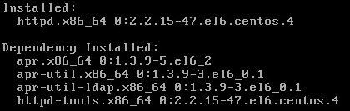

#### Start the httpd service:

sudo service httpd start



#### Set the httpd service to start if server reboots:

sudo chkconfig httpd on

chkconfig_httpd.JPG

No reply is given if the command is valid. We must now verify that the chconfig command actually worked.

Just type the chkconfig command and view results:

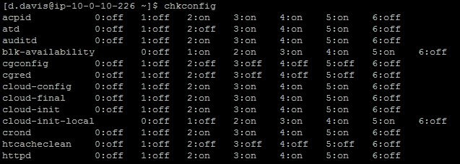

* At the bottom of the image you see the service httpd and the initialization bit is set to 2:on, 3:on, 4:on, 5:on. This means that the service will run in all states of the running server.
* Navigate to your public IP address in your browser. You should see the Apache Default Web Page to verify the Web Server is running.

A LAMP stack consists of a stack of services installed on a server. The particular services are as follows:

**L**inux     (an OS)

**A**pache (a web server service)

**M**ySQL  (or another such SQL database service)

**P**HP      (a server side scripting language allowing for dynamic content on a web page)

#### PHP Installation

I  have found that the installation for me as well as over all operation goes better with the installation of PHP first then MySQL in the process.

Our first step is to install PHP

sudo yum install -y php

yum_php.JPG

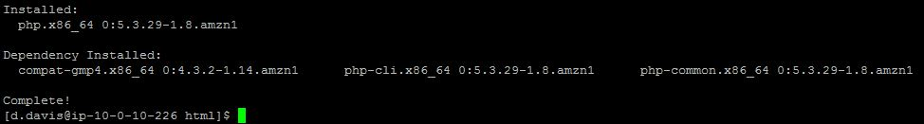

Install PHP-MySQL

sudo yum install -y php-mysql

yum_php-mysql.JPG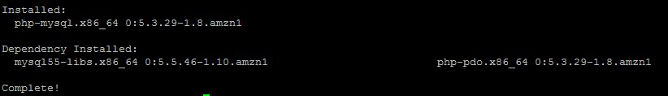

Create a small php program to verify PHP operation.

cd /var/www/html

sudo vi test.php

create_test_php.JPG

Create one line php program by typing the text below on the top line, only on one line. This oneliner returns the information page about the web server. This is not a page you want available to the public at large in a production environment!

<?php phpinfo()?>

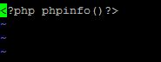

Press esc, use : to enter into command mode and type wq for write quite and then press enter. Your document is saved as long as you wre in sudo or root.

:wq

Restart the httpd service

sudo service httpd restart

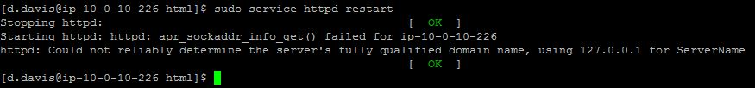

Now enter in your public IP address with /test.php at the end. EX:   [http://54.210.54.74/test.php (Links to an external site.)](http://54.210.54.74/test.php)

You should see something like this in your browser if the file is configured and the httpd service is restarted. If you see a text page of what you wrote in vi then restart the httpd service.

#### Installation of My SQL for use with Apache

Begin installing MySQl and need components with yum:

sudo yum install -y mysql-server

yum_mysql_serv.JPG

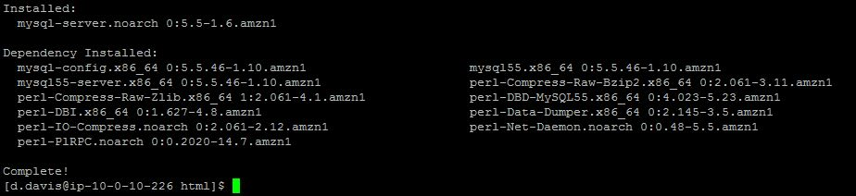

Start MySQL Server

sudo service mysqld start

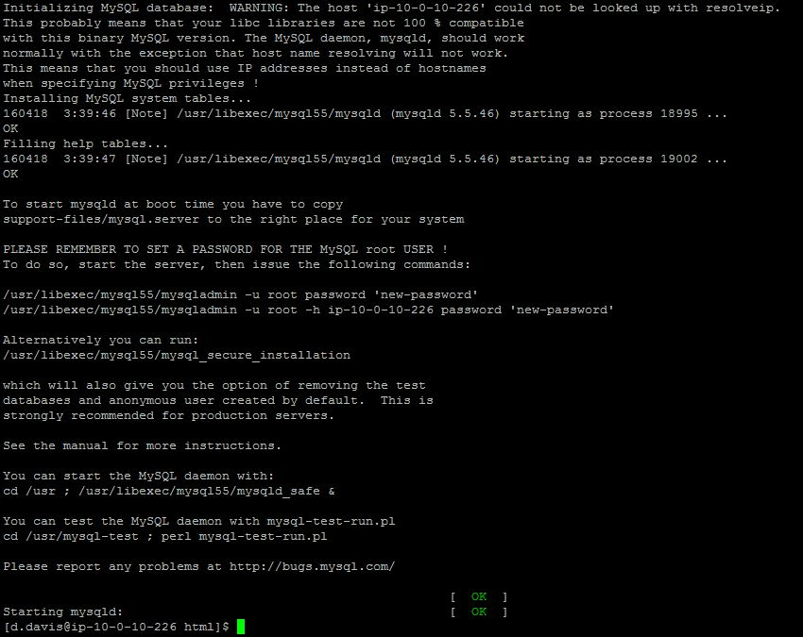

Create and secure a database for use with [LAB 1.3 WordPress Installation](https://clarkcollege.instructure.com/courses/1256564/assignments/7444283)

mysqladmin -uroot create blog

create_blog_dB.JPG

Securing the installation

sudo mysql\_secure\_installation

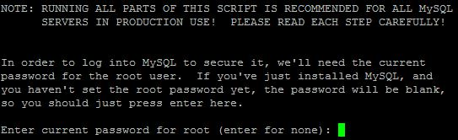

There is no beginning password for root so when prompted press enter

CHANGE ROOT PASSWORD: Y

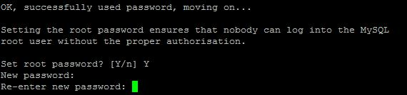

REMOVE ANONYMOUS USER: Y

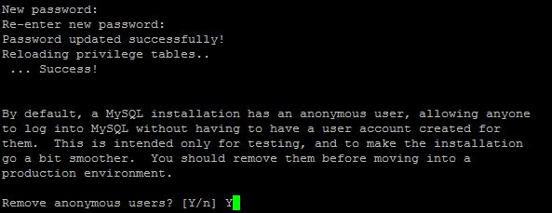

REMOVE ROOT LOGIN REMOTELY: Y

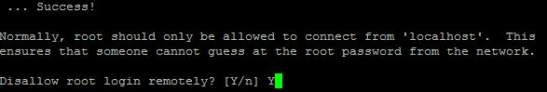

REMOVE TEST DATABASE AND ACCESS TO IT: Y

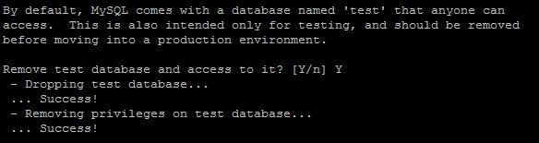

RELOAD PRIVILEGE TABLES NOW: Y

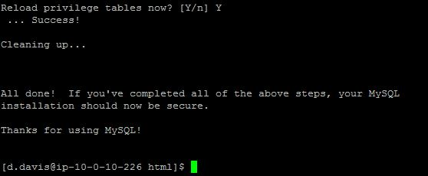

Use the chkconfig command to insure that mysqld is restarted after a server reboot

sudo chkconfig mysqld on

chkconfig_mysqld.JPG

Verify that the service is set with the chkconfig command

chkconfig

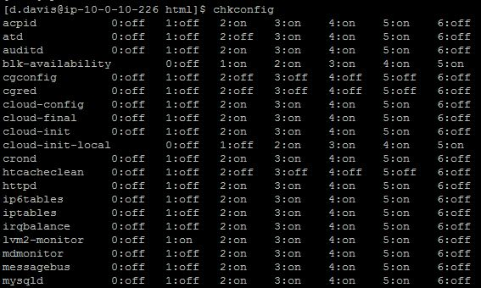

**Make A Backup of httpd.conf File**

Find the httpd.conf file: cd /etc/httpd/conf/

Verify Location Contents

pwd

ls

Copy httpd.conf file to backup directory

cp /etc/httpd/conf/httpd.conf /home/username/httpd/httpd.conf\_bak

Verify Backup Was Created Successfully

ls /home/d.davis/httpd

**>>>>>>>>>>>>>>>>>>>>**

**Install WordPress**

Go to public HTML folder

Cd /var/www/html

Check directory: pwd

Download latest WP build

* sudo wget http://wordpress.org/latest.tar.gz

Install

* sudo tar -xzvf latest.tar.gz

Change WP directory name

Sudo mv wordpress blog

Create a config file

Sudo cp wp-configsample.php wp-config.php

Edit the wp-config file

Sudo vi wp-config

Define user data then save the config file